

**REPORT OF THE COMPANY MEMBERS AND WORK FLOW DISTRIBUTION**

**MEMBERS.**



**Mr. Ganesh Maji.**

Handling Market Statement

*(Leading market space, survey report analysis,*

*demand chain).*

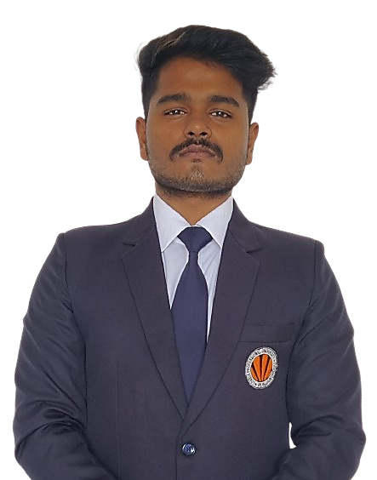

**Mr. Souvik Chakraborty.**

Handling Design Audit

*( Check the design, trending technology analysis).*



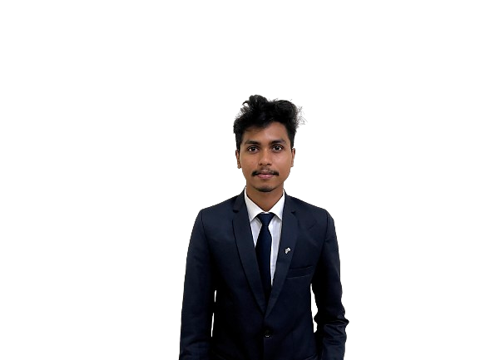

**Mr. Ankit Biswal.**

Handling Embedded System

*(Assemble the parts, validate the project, simulation*

*and Embedded technology handle)*



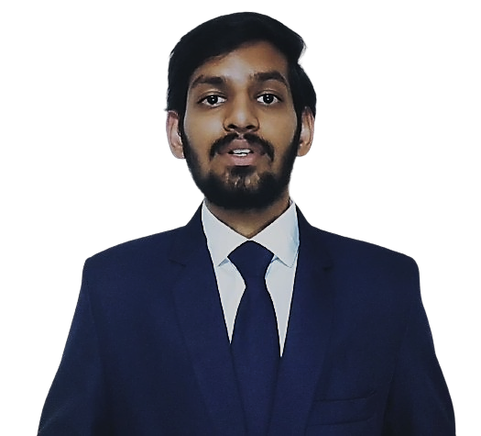

**Mr. Charan Reddy.**

Handling Financial Report.

*(finance, tax, loan, law & order)*



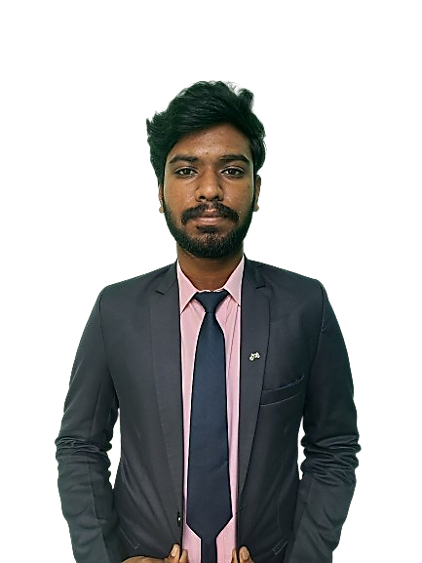

**Mr. Sujiith** .

Handling Distribution and Client relationship.

*(Supply chain, contract note*

*production schedule and departure)*





**Case 1:**

**Name:** *Lovely sweets.* **Category***: Sweets*

**Location:** *Block 15 Uni-mall***.**

**Number of Employees:** *11***.**

**Number of Cashier:** *03*

**Average Salary:** *12,000/-*

**Total No of Products:** *230*

**Average Billing value per user:** *180/- to 260/-*

**Average No of Customer per day:** *400(week days).*

**Target hours Rush hours:** *11am to 6 pm.*

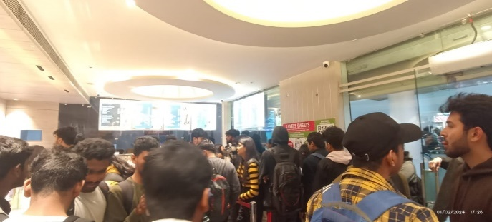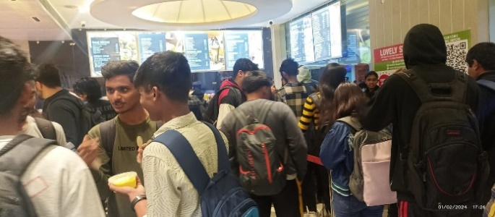

**Image :** *Represents the Rush and queue during the peak rush Hours.*

**Problem Analysis---------------------------------------------------------------------------------------------------**

**Date :** *01-feb-2024*

|  |  |  |  |  |
| --- | --- | --- | --- | --- |
|  | **9am-12pm** | **12pm-3pm** | **3pm-6pm** | **Non Rush Hrs** |
| **Employee** | *2 Cashier, 3 Service, 1 Guard.* | *3 Cashier, 4 Service, 1 Guard* | *3 Cashier, 4 Service, 1 Guard* | *1 Cashier, 3 Service, 1 Guard* |
| **CAC Customer Acquisition cost** | *12 rupees per person* | *12 rupees per person* | *12 rupees per person* | *12 rupees per person* |
| **Market place** |  | **---------UNI - CREME** | **CROWD-------------** |  |
| **Theft Protection**  **Ratio.** | *0.01 : 1000* |  | *0.1 : 1000* | *0.01 : 100* |
| **Crowd Number** | *30(approx)* | *120(approx)* | *60(approx)* | *20(approx)* |
| **Queue** |  |  |  |  |



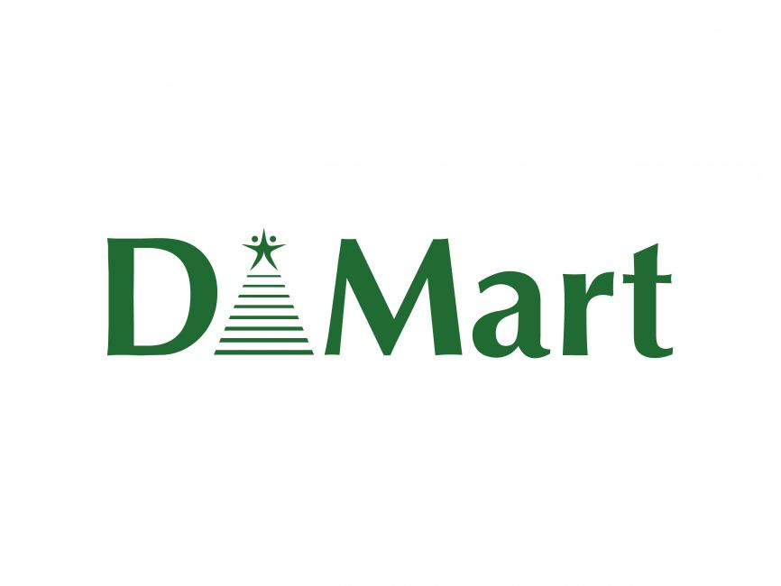

**Case 2:**

**Name:** *D mart.* **Category:** *Grocery.*

**Location: *Mahavir Marg,*** *Jalandhar.*

**Number of Employees:** *66***.**

**Number of Cashier:** *15*

**Average Salary:** *11,000/-*

**Total No of Products:** *30,000+*

**Average Billing value per user:** *3000/- to 7000/-*

**Average No of Customer per day:** *2000(week days).*

**Target hours Rush hours:** *11am to 6 pm.*

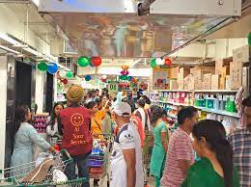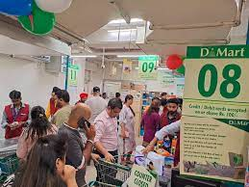

**Image :** *Represents the Rush and queue during the peak rush Hours.*

**Problem Analysis--------------------------------------------------------------------------------------------------------------**

**Date :** *03-feb-2024*

|  |  |  |  |  |
| --- | --- | --- | --- | --- |
|  | **9am-12pm** | **12pm-3pm** | **3pm-6pm** | **Non Rush Hrs** |
| **Employee** | *4 Cashier, 20 Service, 1 Guard.* | *6 Cashier, 20 Service, 2 Guard* | *7 Cashier, 20 Service, 2 Guard* | *6 Cashier, 20 Service, 2 Guard* |
| **CAC Customer Acquisition cost** | *N/A* | **N/A** | *N/A* | *N/A* |
| **Market place** |  | **---------UNI - CREME** | **CROWD-------------** |  |
| **Theft Protection**  **Ratio.** | *0.1 : 100* |  | *0.1 : 100* | *0.1 : 1000* |
| **Crowd Number** | *30(approx)* | *120(approx)* | *60(approx)* | *20(approx)* |
| **Queue** |  |  |  |  |



**Case 3:**

**Name:** *Zudio.* **Category:** *Fashion & Clothing.*

**Location: *Mahavir Marg,*** *Jalandhar.*

**Number of Employees:** *66***.**

**Number of Cashier:** *15*

**Average Salary:** *11,000/-*

**Total No of Products:** *30,000+*

**Average Billing value per user:** *3000/- to 7000/-*

**Average No of Customer per day:** *2000(week days).*

**Target hours Rush hours:** *11am to 6 pm.*

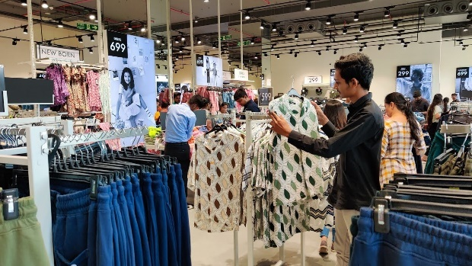 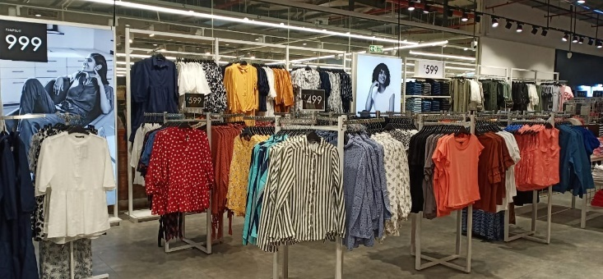

**Image :** *Represents the Rush and queue during the peak rush Hours.*

**Problem Analysis---------------------------------------------------------------------------------------------------**

**Date :** *01-feb-2024*

|  |  |  |  |  |
| --- | --- | --- | --- | --- |
|  | **9am-12pm** | **12pm-3pm** | **3pm-6pm** | **Non Rush Hrs** |
| **Employee** | *4 Cashier, 20 Service, 1 Guard.* | *6 Cashier, 20 Service, 2 Guard* | *7 Cashier, 20 Service, 2 Guard* | *6 Cashier, 20 Service, 2 Guard* |
| **CAC Customer Acquisition cost** | *N/A* | **N/A** | *N/A* | *N/A* |
| **Market place** |  | **---------UNI - CREME** | **CROWD-------------** |  |
| **Theft Protection**  **Ratio.** | *0.1 : 100* |  | *0.1 : 100* | *0.1 : 1000* |
| **Crowd Number** | *30(approx)* | *120(approx)* | *60(approx)* | *20(approx)* |
| **Queue** |  |  |  |  |



**Case 4:**

**Name:** *Reliance SMART.* **Category:** *Fashion & Clothing.*

**Location: *Mahavir Marg,*** *Jalandhar.*

**Number of Employees:** *66***.**

**Number of Cashier:** *15*

**Average Salary:** *11,000/-*

**Total No of Products:** *30,000+*

**Average Billing value per user:** *3000/- to 7000/-*

**Average No of Customer per day:** *400(week days).*

**Target hours Rush hours:** *11am to 6 pm.*

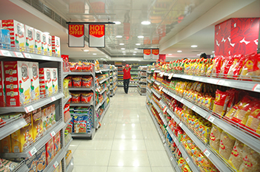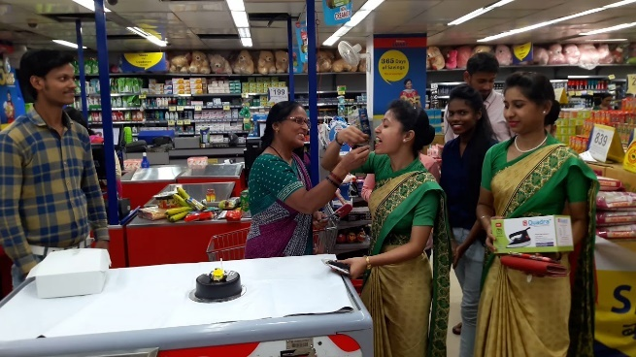

**Image :** *Represents the Rush and queue during the peak rush Hours.*

**Problem Analysis---------------------------------------------------------------------------------------------------**

**Date :** *01-feb-2024*

|  |  |  |  |  |
| --- | --- | --- | --- | --- |
|  | **9am-12pm** | **12pm-3pm** | **3pm-6pm** | **Non Rush Hrs** |
| **Employee** | *4 Cashier, 20 Service, 1 Guard.* | *6 Cashier, 20 Service, 2 Guard* | *7 Cashier, 20 Service, 2 Guard* | *6 Cashier, 20 Service, 2 Guard* |
| **CAC Customer Acquisition cost** | *N/A* | **N/A** | *N/A* | *N/A* |
| **Market place** |  | **---------UNI - CREME** | **CROWD-------------** |  |
| **Theft Protection**  **Ratio.** | *0.1 : 100* |  | *0.1 : 100* | *0.1 : 1000* |
| **Crowd Number** | *30(approx)* | *120(approx)* | *60(approx)* | *20(approx)* |
| **Queue** |  |  |  |  |



** **

**Case 5:**

**Name: *MBD*** *neo polis.* **Category:** *Service Store.*

**Location: *Mahavir Marg,*** *Jalandhar.*

**Number of Employees:** *66***.**

**Number of Cashier:** *15*

**Average Salary:** *11,000/-*

**Total No of Products:** *30,000+*

**Average Billing value per user:** *3000/- to 7000/-*

**Average No of Customer per day:** *400(week days).*

**Target hours Rush hours:** *11am to 6 pm.*

**Image :** *Represents the Rush and queue during the peak rush Hours.***.**

**Problem Analysis--------------------------------------------------------------------------------------------------------------**

**Date :** *01-feb-2024*

|  |  |  |  |  |
| --- | --- | --- | --- | --- |
|  | **9am-12pm** | **12pm-3pm** | **3pm-6pm** | **Non Rush Hrs** |
| **Employee** | *4 Cashier, 20 Service, 1 Guard.* | *6 Cashier, 20 Service, 2 Guard* | *7 Cashier, 20 Service, 2 Guard* | *6 Cashier, 20 Service, 2 Guard* |
| **CAC Customer Acquisition cost** | *N/A* | **N/A** | *N/A* | *N/A* |
| **Market place** |  | **---------UNI - CREME** | **CROWD-------------** |  |
| **Theft Protection**  **Ratio.** | *0.1 : 100* |  | *0.1 : 100* | *0.1 : 1000* |
| **Crowd Number** | *30(approx)* | *120(approx)* | *60(approx)* | *20(approx)* |
| **Queue** |  |  |  |  |

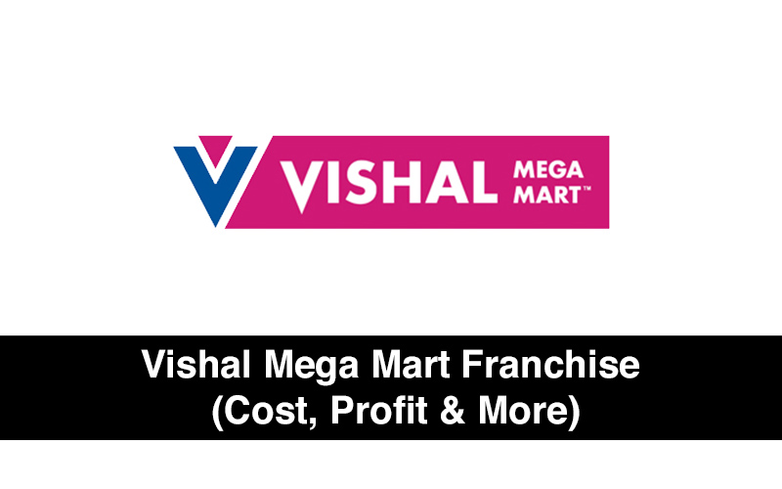

**Case 6:**

**Name: *MBD*** *neo polis.* **Category:** *Service Store.*

**Location: *Mahavir Marg,*** *Jalandhar.*

**Number of Employees:** *66***.**

**Number of Cashier:** *15*

**Average Salary:** *11,000/-*

**Total No of Products:** *30,000+*

**Average Billing value per user:** *3000/- to 7000/-*

**Average No of Customer per day:** *400(week days).*

**Target hours Rush hours:** *11am to 6 pm.*

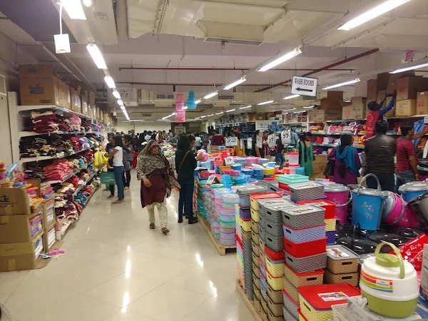 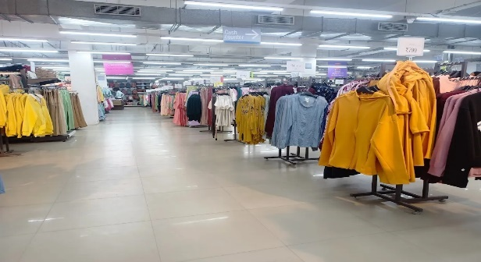

**Image : Represents the Rush and queue during the peak rush Hours.**

**Problem Analysis--------------------------------------------------------------------------------------------------------------**

**Date :** *01-feb-2024*

|  |  |  |  |  |
| --- | --- | --- | --- | --- |
|  | **9am-12pm** | **12pm-3pm** | **3pm-6pm** | **Non Rush Hrs** |
| **Employee** | *4 Cashier, 20 Service, 1 Guard.* | *6 Cashier, 20 Service, 2 Guard* | *7 Cashier, 20 Service, 2 Guard* | *6 Cashier, 20 Service, 2 Guard* |
| **CAC Customer Acquisition cost** | *N/A* | **N/A** | *N/A* | *N/A* |
| **Market place** |  | **---------UNI - CREME** | **CROWD-------------** |  |
| **Theft Protection**  **Ratio.** | *0.1 : 100* |  | *0.1 : 100* | *0.1 : 1000* |
| **Crowd Number** | *30(approx)* | *120(approx)* | *60(approx)* | *20(approx)* |
| **Queue** |  |  |  |  |

**DESIGN BLUE PRINT :**

****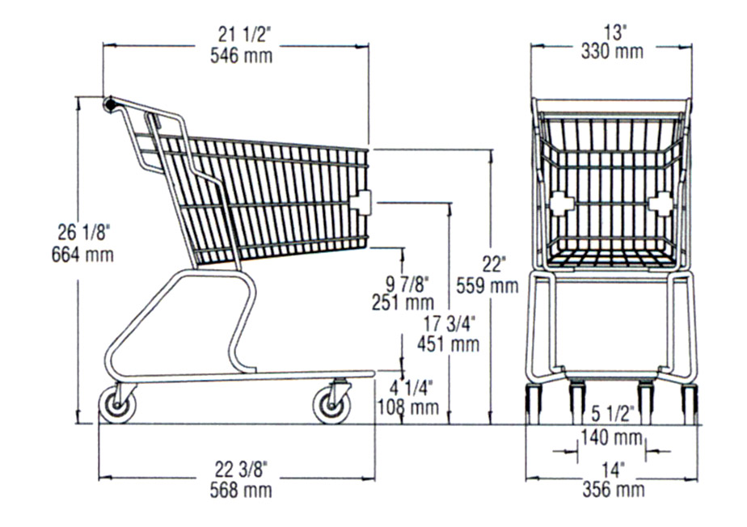

Base elongated with segmented weight integration.

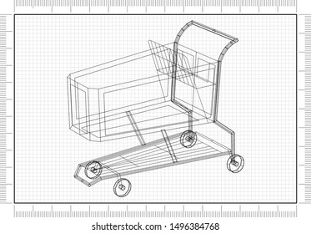

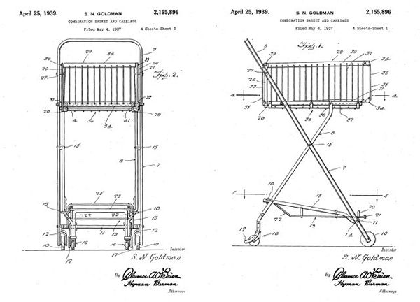

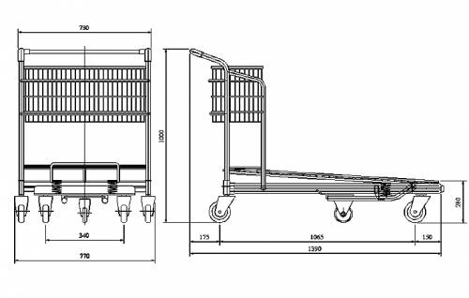



Heavy machineries in the warehouse



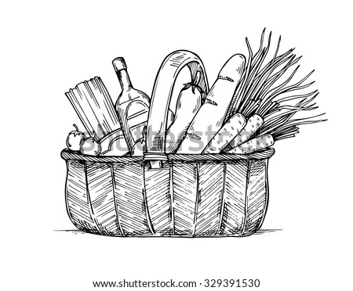

*The compilation processWhen you press the 'compile' button, the IDE savesthe current file as arduino.c in the 'lib/build' directorythen it calls a makefile contained in the 'lib' directory.This make file copies arduino.c as prog.c into 'lib/tmp'adding 'wiringlite.inc' as the beginning of it. thisoperation makes the arduino/wiring code into a properc file &#40;called prog.c&#41;.After this, it copies all the files in the 'core' directoryinto 'lib/tmp'. these files are the implementation of thevarious arduino/wiring commands adding to thesefiles adds commands to the coding language.The core files are supported by pascal stang's procyonavr-lib that is contained in the 'lib/avrlib' directoryAtthis point the code contained in lib/tmp is ready to becompiled with the c compiler contained in 'tools'. Ifthe make operation is succesfull then you'll haveprog.hex ready to be downloaded into the processor.*



*REFERENCES*

*[1].*

*Smart Shopping Trolley Using RFID Based on IoT,International Journal of Innovative Research inComputer and Communication Engineering 2017[2].*

*Smart Shopping Cart, IJEDR 2018 | Volume 6,Issue 2 | ISSN: 2321-9939[3].*

*Intelligent Shopping Cart Using Bolt Esp8266Based on Internet of Things,[4].*

*IoT based retailed shopping system using NFC,International Journal of Advance Research, Ideasand Innovations in Technology 2018[5].*

*Rfid Based Smart Trolley, 2019 IJRTI | Volume 4,Issue 4 | ISSN: 2456-3315*

****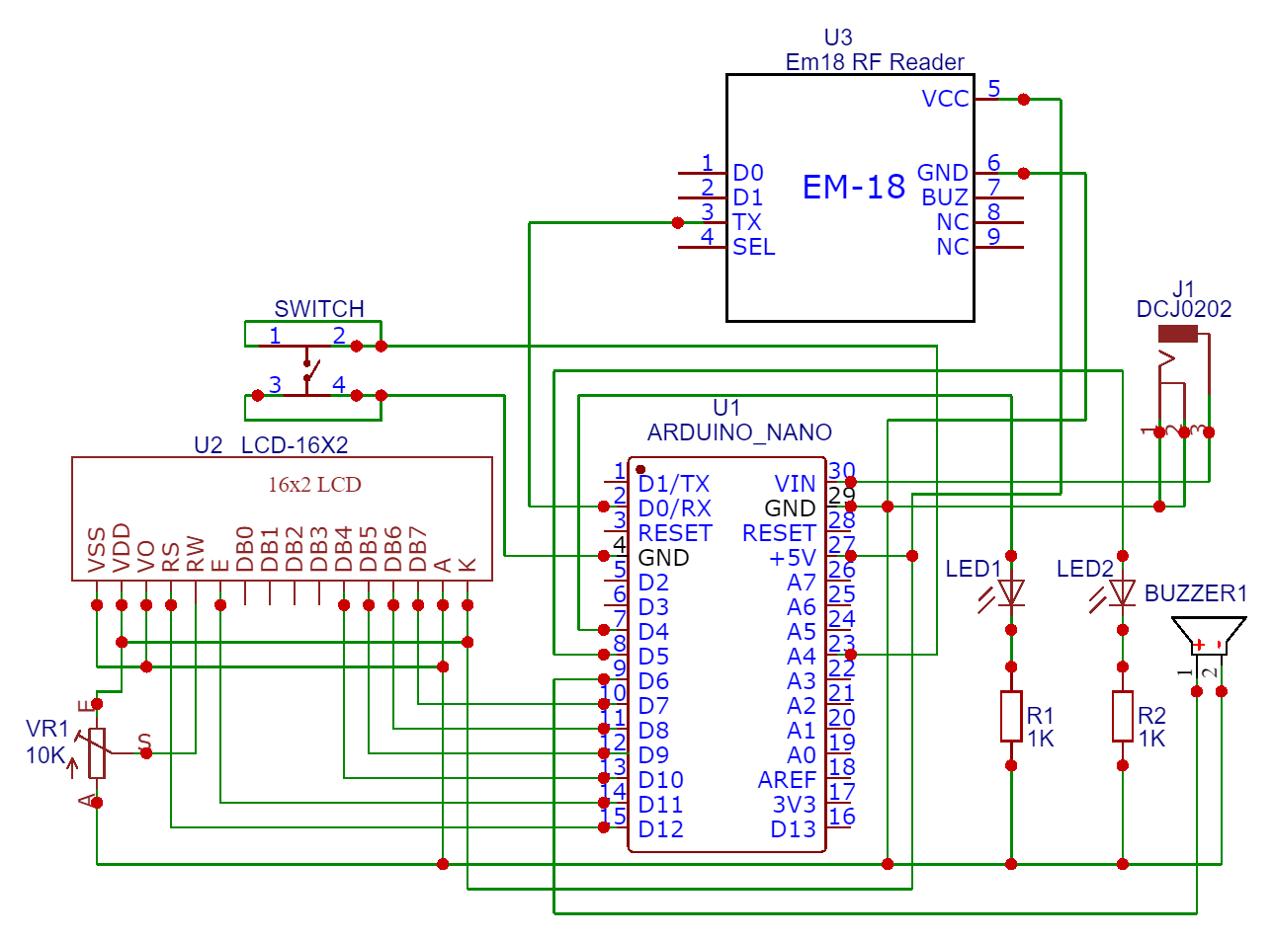

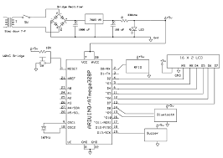

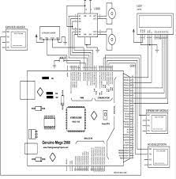

****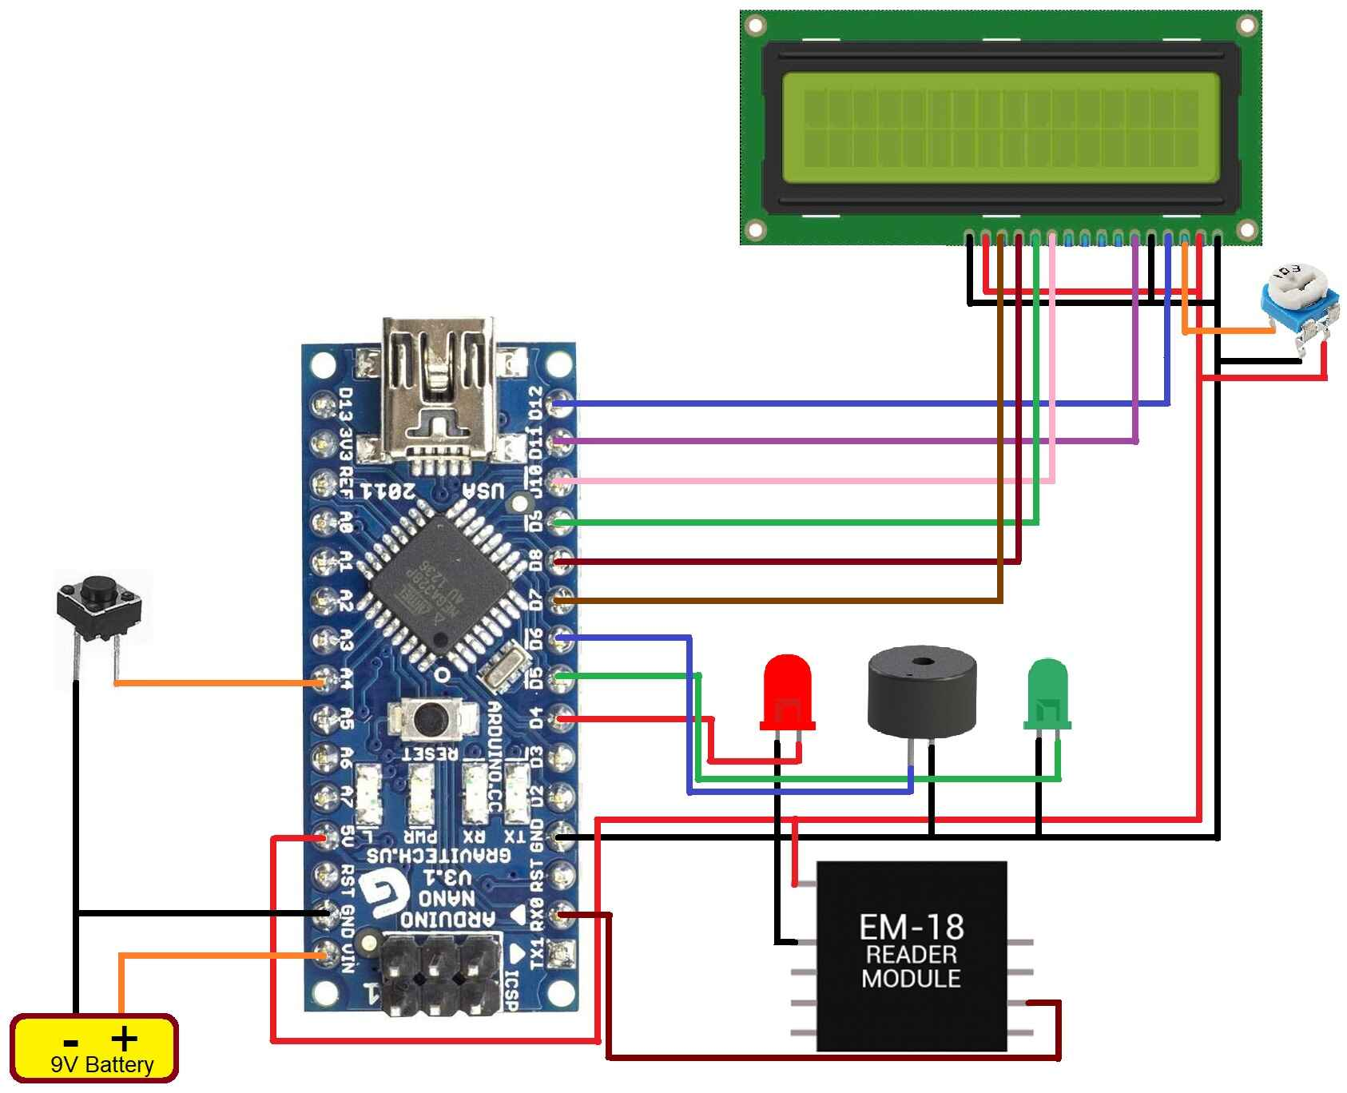

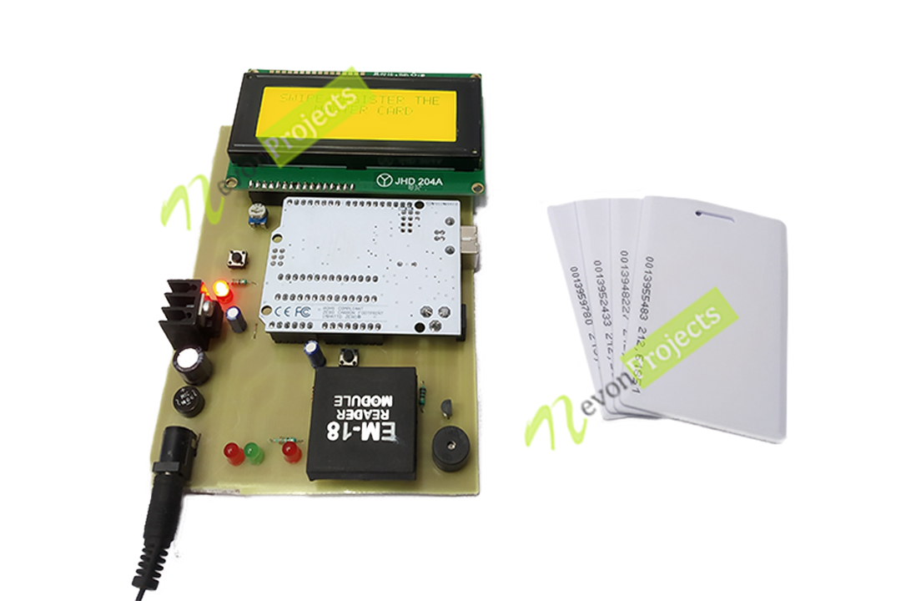



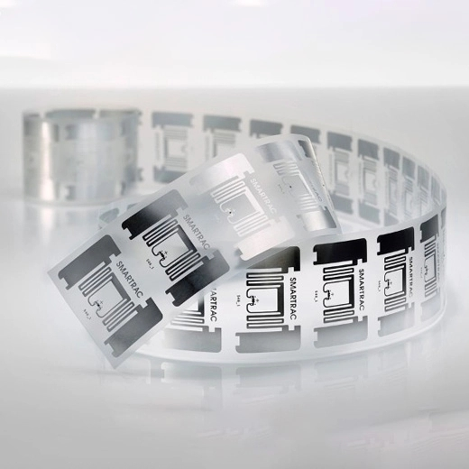

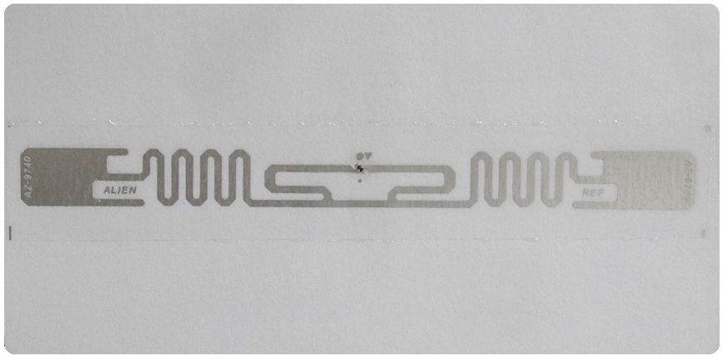



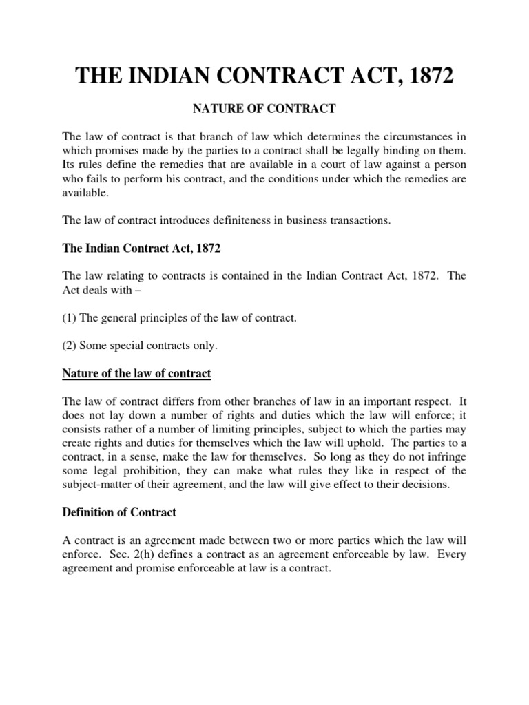

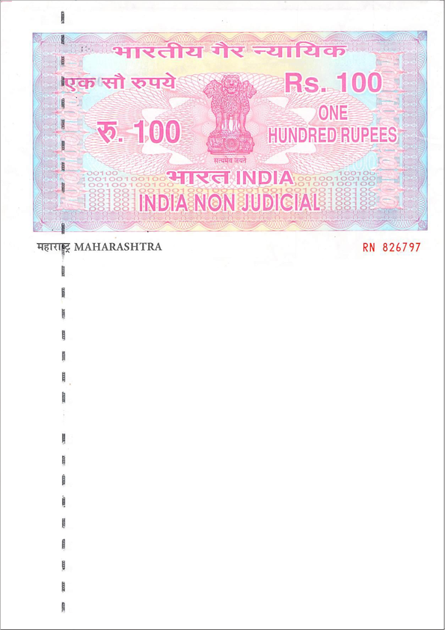****

*[Vasturath by Ankit Date]*

*[Your Company Logo]*

*CART AUTOMATION SERVICE AGREEMENT*

*This Cart Automation Service Agreement (the "Agreement") is entered into on [Date], by and between Vasturath by Ankit Date, a [Your State/Country] corporation, with its principal place of business at [Your Company Address] (hereinafter referred to as the "Service Provider"), and [Client's Name], a [Client's State/Country] resident, with its principal place of business at [Client's Address] (hereinafter referred to as the "Client").*

*1. SCOPE OF SERVICES:*

*The Service Provider, Vasturath by Ankit Date, agrees to provide cart automation services to the Client for their shop located at [Shop Address]. The services include the provision of automated shopping carts on a contractual basis.*

*2. TERMS OF CONTRACT:*

*2.1 The contract term shall commence on [Start Date] and shall continue for a period of [Contract Duration] unless terminated earlier as per the terms of this Agreement.*

*2.2 Either party may terminate this Agreement with [X] days written notice if the other party breaches any material term of this Agreement.*

*3. SERVICE FEES:*

*3.1 The Client agrees to pay Vasturath by Ankit Date the agreed-upon service fees as outlined in Exhibit A attached hereto.*

*3.2 Payment shall be made [monthly/quarterly/annually] in advance, and the first payment shall be due on [Due Date].*

*4. CART MAINTENANCE:*

*4.1 Vasturath by Ankit Date shall be responsible for the regular maintenance and upkeep of the automated shopping carts.*

*By: ___________________________ By: ____________________________*

*[Your Name], [Your Title] [Client's Name], [Client's Title]*

*Date: ________________________ Date: ________________________*

|  |  |  |  |  |  |
| --- | --- | --- | --- | --- | --- |
|  | Nos | Model | Length | Cost off. | Cost  On. |
| Rfid Tag | *10* | *INKJET PRINTER ORDER NANO RFID* |  |  |  |
| Rfid Reader | *1* | *RC522 MFRC 522 RFID* |  |  |  |
| Weight Dist. Balancing Sensor | *4* |  |  |  |  |
| Cart | *1* | *60 L – RD SHOPPING ROLLING* |  |  |  |
| Ardiuno | *1* | *ARDIUNO - MEGA* |  |  |  |
| PCB board | *1* |  |  |  |  |
| Wire | *6* |  |  |  |  |
| Jumper | *10* |  |  |  |  |
| Display | *1* |  |  |  |  |
| Battery | *2* |  |  |  |  |
| Memory | *1* |  |  |  |  |
|  |  |  |  |  |  |

|  |  |  |  |  |  |  |  |  |
| --- | --- | --- | --- | --- | --- | --- | --- | --- |
|  | Category Type | Subscription | Fund required | Mode of selling | Target location | Profit Ratio | No.of.sale  Should be. | Mode |
| Model 1 | *GROCERY SH. CART* | *85 – 135* | *7000* | *BULK - SUB* | *CITY* |  | *100* |  |
| Model 2 | *HEAVY CART* | *70 – 80* | *5000* | *BULK –*  *SUB* | *IND.* |  | *100* |  |
| Model 3 | *FRUIT/ SWEET BASKET* | *N/A* | *2800* | *DIRECT* | *UNI/ MALL* |  | *1 OR ABOVE* |  |
| Model 4 | *CLOTH SHOPPING CART* | *203 - 220* | *3000* | *BULK - SUB* | *MALL* |  | *100* |  |



|  |  |  |
| --- | --- | --- |
|  | Mode | Marketing |
| Model 1 | *7 INCH DISPLAY* | *0.06 PER USER* |
| Model 2 | *NO* | *NO* |
| Model 3 | *PHONE* | *0.09 PER USER* |
| Model 4 | *DISPLAY* | *0.06 PER USER* |

|  |  |  |
| --- | --- | --- |
|  | Production quantity | Marketing |
| Model 1 | *100* | *CONTRACT 3* |
| Model 2 | *100* | *CONTRACT 3* |
| Model 3 | *1* | *B2C* |
| Model 4 | *100* | *CONTRACT 3* |

|  |  |  |  |  |
| --- | --- | --- | --- | --- |
|  | Payment Mode | User Base | Transaction cost | Profit Percentage |
| Model 1 | *UPI / CARD* | *2000* | *0.3* | *1.2* |
| Model 2 | *NO* | *NO* | *NO* | *NO* |
| Model 3 | *UPI / CARD* | *2000* | *0.3* | *1.2* |
| Model 4 | *UPI /CARD* | *2000* | *0.3* | *1.2* |



|  |  |  |
| --- | --- | --- |
|  | CGST | SGST |
| Model 1 |  |  |
| Model 2 |  |  |
| Model 3 |  |  |
| Model 4 |  |  |



TIME





ROI

****



